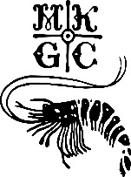
MKGC LADIES MEMBERSHIP FEES

SCHEME 1
For New Lady Members Only
Subscription fees reduced by 50% in the first year, 30% year 2, 20% year 3 and 10% year 4.
To include 4 free lessons
New ladies Joining Fees may be paid over three years (£250 p/annum).

SCHEME 2
For New Lady Members Only
A 6 month Academy (“Get into Golf”) membership costing £350 in subscriptions including 6 free lessons. (Play allowed weekdays and weekends PM only).
Additional payment of £150 subscription fee to extend a further 6 months.
Joining fee of £200 initially, a further £200 if extended by 6 months. Full fees and remainder of joining fee apply year 2.

