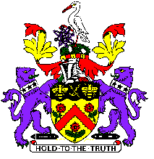

Code of Conduct for Junior Players

You Should
- Welcome new players into the club
- Help create and maintain an environment free of fear and harassment
- Demonstrate fair play and apply golf’s standards both on and off the course
- Understand that you have the right to be treated as an individual
- Respect the advice that you receive that promotes the concept of a balanced attitude
- Treat others as you would wish to be treated yourself
- Respect physical, cultural and racial differences - challenge or report if you observe any form of discrimination and prejudice
- Look out for yourself and for the welfare of others
- Speak out if you consider that you or others have been poorly treated
- Be organised and on time
- Tell someone in authority if you are leaving a venue or competition
- Accept that these guidelines are in place for the well-­‐being of all concerned
- Treat organisers and coaches with respect
- Observe instructions or restrictions required by appropriate members of staff
You should not take part in any irresponsible, abusive, inappropriate or illegal behaviour which includes:
- Consuming alcohol or illegal or performance-­‐enhancing drugs or stimulants
- Smoking
- Using foul language
- Publicly using critical or disrespectful descriptions of others, including posting hurtful comments on social networking sites.

Burnley Golf Club Welfare Officer Junior Organiser
Kate Walne Ian Duffy

