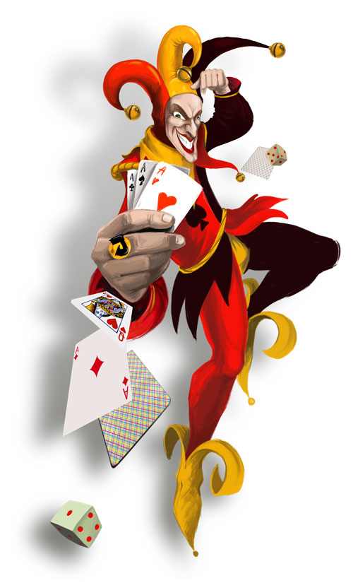
CHASE THE JOKER
FIRST DRAW WINNER – Robert McGinty…wins £25
NEXT WEEK`S JACKPOT £161
GET YOUR TICKETS PRICED £1.00 AT THE BAR
SPOT PRIZE : PICK A JACK-WIN A BOTTLE OF WHISKY/VODKA

