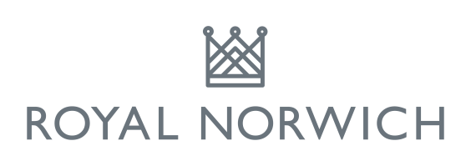
CHRISTMAS OPEN
Friday 28th December 2018
10.30 am shotgun start - Betterball Stableford

Coffee on arrival
1 course carvery
Nearest the pins & extensive prize table
Refreshments on course

Entry fee:
£50 per pair (visitors)
£30 per pair (members)

Lead name …………………………………….…………..………………………....................................................
Club……………………………………………….………….. CDH No………………………………………
Address:………………………………………………………………………………....…………………………………………………………………………………………...Tel:………………………………………….. Email……………………………………………………………..
Partner……………………………………………………….…..
Club…………………………………………………………...CDH No………………………….……………

In accordance with the GDPR 2018 please indicate you and your partner’s preference by ticking the boxes below: YES NO

We agree the above names can be posted on the draw sheet and displayed on the noticeboard/website at Royal Norwich Golf Club.

We agree the above names and/or photograph may be used in any post competition publicity e.g. press/website/social media

Signed……………………………………………………………….(Player 1)……………………………………….……………………..(Player 2)

Completed entry form (including SAE if you require start time to be posted) with a cheque payable to ‘Royal Norwich Golf Club Limited’ to: Royal Norwich Golf Club, Drayton High Road, Hellesdon, Norwich. NR6 5AH

