History of the Lands of Old Conna Golf Club.

Old Conna Golf Club is situated on the beautiful side slopes of Carrickgollen. It is one of the foremost sites in the area resting at just above the 200 ft. contour lines from sea level with extensive views to Killiney Hill and Bay, along with superb views of Bray and the Wicklow Mountains.

Old Conna Golf Club was established in 1987, following the purchase of 128 acres of land, which was formerly part of the Old Conna Hill House Estate, by the members of Dublin Sport Golf Club (D.S.G.C.).
Dublin Sport Golf Club was established in 1977, when green fee members of the Dublin Sport Hotel came together with the Management of the Dublin Sport Hotel to found the club. The D.S.G.C. was granted a yearly licence to play golf, but had no actual tenancy rights.
Over the following years, the officers of the club had formed a Development Committee and in 1983 appointed Eddie Hackett, one of the foremost golf course designers, as their adviser. Following an extensive search of approx 16 sites, the property now housing Old Conna Golf Club was purchased from developer, Owen McDermott, in 1986. The development of the course took place following Eddie Hackett’s design with the grand opening taking place over the weekend of 11th 12th and 13th July 1987.

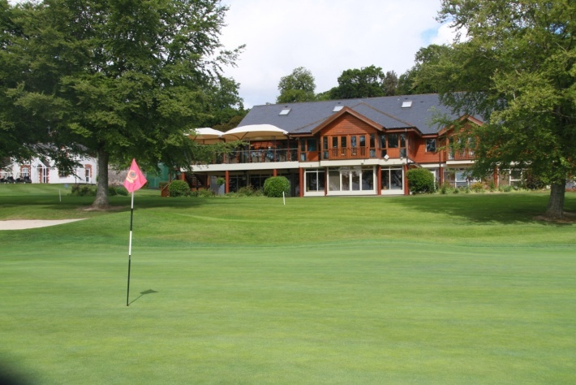
Clubhouse 1987
Clubhouse 2017

The land occupied by Old Conna has a long and interesting history. The first mention we find is that in the 13th century the lands were owned by the Knights Templar, with many ownership changes taking place over the next centuries. At the beginning of the 15th century the lands of Old Connaught were owned by Thomas Lawless, and later by Hugh Lawless. In the 16th century all the lands in the parish of Old Connaught slowly came into the possession of the Walshe family except those of Ballyman. The lands of Ballyman passed from the Knights Templar to the Priory of Saint John of Jerusalem at Kilmainham.

After the dissolution of The Monasteries by Henry VIII the lands of Old Connaught were granted to Peter Talbot while the Walshe family retained possession of Old Connaught and Corke (Little Bray).
Following the establishment of the Commonwealth, the Walshe property in Old Connaught parish, including Old Connaught, Corke and part of Little Bray were disposed of and the Walshe family withdrew to France. Later following the Restoration, the lands were returned to the families.

The family of Roberts represented by Captain Lewis Riall D. L. appear about the middle of the 18th century as owners of what was the Walshe’s property in Old Connaught parish. The first Roberts family connected with Old Connaught was Mr Lewis Roberts, eldest son of the Member of Parliament for Dungarvan, Dr Robert Roberts, a resident of Monkstown Castle, and a cousin of Dr William Roberts who resided at Coldblow near Donnybrook. They were descended from an ancient Welsh family of which the father of Dr. William Roberts appears to have been the first member of the family to come to Ireland.

Mr Lewis Roberts was an extensive land owner in the area. He does not appear to have resided in Old Connaught House, which is situated on the left hand side of Ferndale Road heading towards Bray from O.C.G.C. while possibly having resided in Shanganagh Castle. In 1765, the recognition and a Gold Medal was awarded to him by The Royal Dublin Society, for reclaiming lands and planting 38,000 trees which he had planted on the Shanganagh Estate from 1750 onwards. Some of which still exist as far down as Corbawn Lane, Shankill, which was laid out as a grand Avenue originally.

It appears that the first Cordlyline trees to be planted in Ireland in the 1870’s were imported by Mr Lewis Roberts, along with many other rare plants. Old Conna boasted many specimen Redwoods, Rhododendrons, Azaleas, Tree Peonies and Magnolias. Some of these trees still exist, and are mentioned in Champion Trees, A Selection of Great Trees of Ireland, published by the Tree Council of Ireland as follows:
Quercus pyrenaica (Pyrenean Oak) an Irish Height & Girth Champion 3.13 x 21.5m
Torreya californica (California Nutmeg) 2.86 x 18m
Quercus x hispanica ‘Diversifolia’ ( Holm Oak/Evergreen Oak) Irish Height & Girth Champion. 2.76 x 18.5m
Picconia excelisa (Picconia) Irish Height & Girth Champion 2.36 x 15m
One of the more unusual specimen trees or shrubs from this era mentioned in a report by our member, Mr Jack Gardiner is the Arbutus unedo or strawberry tree, which still exists alongside the 5th Tee box. It was originally a native to the Mediterranean and does not appear naturally in Britain or the Eastern part of Ireland. It is though, a part of the natural habitat of the flora of Killarney.

Mr Lewis Roberts was succeeded by his son, Mr John Roberts and his wife Anne. They built a house on Old Conna Hill, Mount Eden, sometime in the latter part of the 18th century. Mount Eden was situated somewhere between our 10th Tee and Aravon School, now John Scottus School.

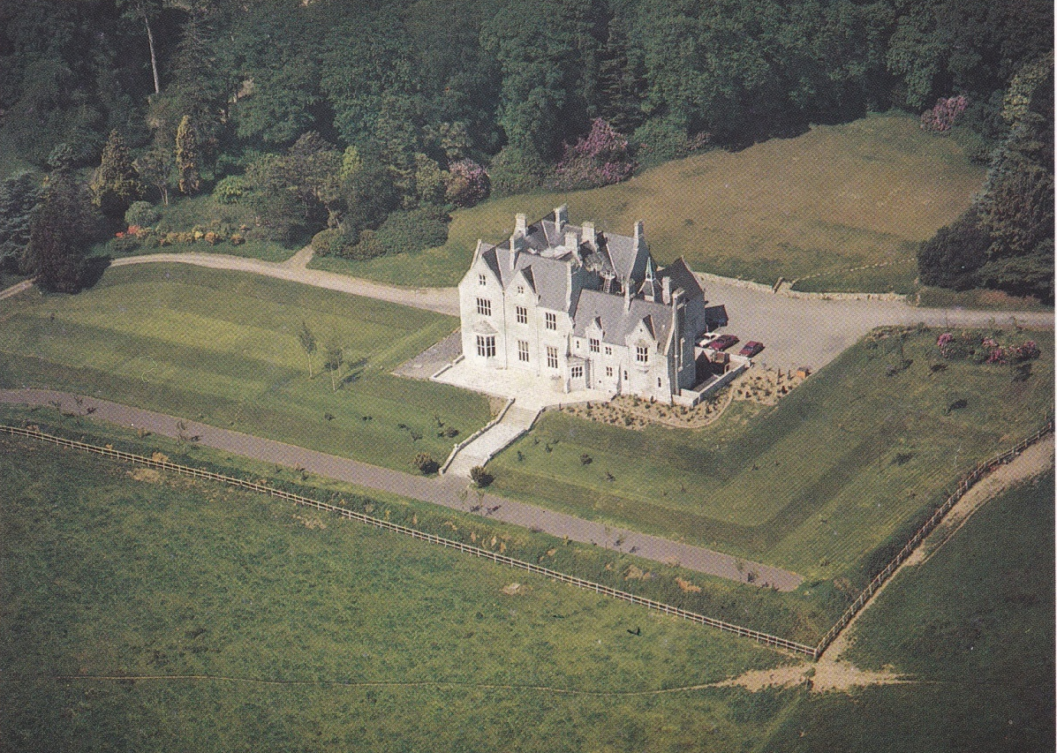
Old Conna Hill House 1980’s

The site on which our clubhouse sits was part of the original walled garden of Mount Eden. As John and Anne Roberts had no male heir, the estate and Mount Eden was passed down to their daughter Anne in 1801, who had married Mr Charles Riall of Clonmel.

Mount Eden was shown on a Map in 1810. It was replaced by Old Conna Hill House in 1860 by Mr Phineas Riall, son of Anne and Charles Riall.

It was through the marriage also of a sister of Mr Charles Riall, who married General Sir George Cockburn of Shanganagh Castle that the Riall family inherited the Shanganagh Estate which included all the lands of Shanganagh, Old Connaught, parts of Shankill and Little Bray. The Shanganagh Estate itself was an extensive holding of land, which extended from Old Connaught down to Shanganagh Castle and northwards towards the Loughlinstown river at Shanganagh Bridge.

Phineas Riall was succeeded by his son, Captain Lewis Riall R.N. and he in turn by his daughter Edith who was unmarried. Her cousin, Colonel Claud Riall, son of Commander Arthur Riall of Chantilly, Ballybride Road, Shankill inherited the Estate in 1947. The family Coat of Arms is located in the porch of the former Old Conna Hill House.

On the 25th March 1953, 232 acres of this estate was transferred to Universal Properties Ltd., while on the same day a Licence was granted to allow water from the main Vartry pipeline to be pumped to a neighbouring property, in perpetuity.
On 3rd December 1957, approx 71 acres of this land was transferred and on the 9th September 1958, 162 acres was transferred, along with the Mansion House to Johns Ltd. & Associates.
On 10th February 1977, the transfer of 1958 was further transferred to M B J Cadogan and a Hotel was established in the Mansion House called the Old Conna Hotel.
On 22nd December 1983 part of those lands were conveyed to Aravon School along with the Mansion House (Old Conna Hill House) where Aravon School operated until very recently.
The remaining portion of the lands were subsequently purchased by Bonynge Ltd. and Owen McDermott in May 1984. Plans were immediately drawn up to develop a golf course on the site, along with proposals for a number of substantial houses.
On the 3rd July 1986, John Mooney, Dermot P Hitchcock and John Byrne (John L) as Trustees, signed for the purchase of the Lands on behalf of the Dublin Sport Golf Club.
And as the saying goes “ The Rest Is History”.

Reference materials, including
“Festina Lente Walled Victorian Gardens Information & History” Festina Lente, and
“Between the Mountains and the Sea” Pearson.
Old Conna Hill House (early 1980’s) photo taken from Jones Lang Wooten, Particulars of Sale
Original Clubhouse photo from Old Conna History & Archive
Current Old Conna Clubhouse photo taken recently by Brendan Connolly.

