**45th Hermitage Scratch Cup**

**1st May 2016**

|  |  |  |  |  |  |
| --- | --- | --- | --- | --- | --- |
| **Place** | **Name and Club** | **H/C** | **Total** | **R1** | **R2** |
| **Winner** | **Ciara Casey - Hermitage** | **0** | **150** | **77** | **73** |
| **Runner Up** | **Elisa Corcoran - Grange** | **5** | **150** | **74** | **76** |
| **3rd** | **Mary Doyle – The Heath** | **1** | **153** | **81** | **72** |
| **4th** | **Louise Coffey - Malone** | **2** | **155** | **78** | **77** |
| **5th** | **Lisa O’Shea - Shannon** | **5** | **155** | **76** | **79** |
| **6th** | **Deirdre Smith – Co. Louth** | **1** | **157** | **78** | **79** |
| **7th** | **Rachel McDonnell (Elm Park)** | **5** | **157** | **78** | **79** |
| **8th** | **Sheena McElroy (Grange)** | **3** | **160** | **80** | **80** |
|  |  |  |  |  |  |
| **Best Nett 36 Holes** | **Leah Temple Lang – Elm Park** | **11** | **144** | **72** | **72** |
| **2nd Best Nett 36 Holes** | **Kate Lanigan - Hermitage** | **7** | **146** | **71** | **75** |
| **Best Gross Round 1** | **Kate Whyte – Lucan** | **4** | **78** | **78** |  |
| **Best Gross Round 2** | **Nicola Coffey - Woodbrook** | **2** | **79** |  | **79** |
| **Best Nett Round 1** | **Katie Keenan - Kilkenny** | **10** | **75** | **75** |  |
| **Best Nett Round 2** | **Hilary Hall - Enniscrone** | **9** | **71** |  | **71** |
| **Senior Prize Nett 36** | **Mary Duane - Hermitage** | **6** | **156** | **82** | **74** |
| **Junior Prize Nett 36** | **Georgia Carr - Milltown** | **10** | **148** | **77** | **71** |

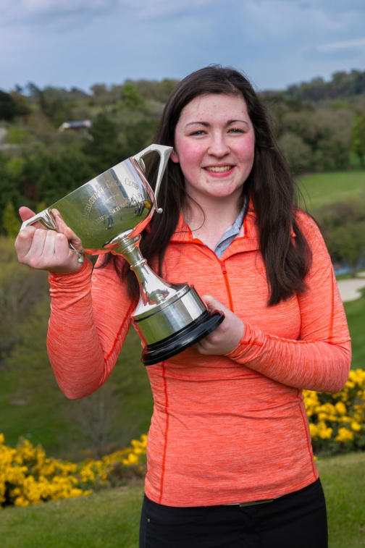**Ciara Casey Winner of the Hermitage Scratch Cup**