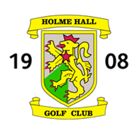

JUNIOR SPONSORED OPEN
SPONSOR’S COMPETITION
WEDNESDAY 14 AUGUST 2019
18 Holes Better-Ball Stableford – 90% Handicap
Competition Handicaps required
Handicap Certificates will be required at registration
Ties to be decided on the last 9, 6, 3, 2 or 1 hole(s) (i.e. holes 10-18 on the course)

Sponsors Fee - £60.00 – including meal after play

SPONSOR’S NAME / COMPANY NAME
Player 1  (please print full name)  Contact address  (please print full address  including post code)  Email address | Telephone numbers | Handicap
Player 2  (please print full name) |  | Handicap
Preferred tee time 10.00am onwards
(please tick)

Every consideration will be given to meeting your preference, but this cannot be guaranteed.

Please return the entry form together with a cheque for the entry fee (payable to Holme Hall Golf Club)
to
The Manager, Holme Hall Golf Club, Holme Lane, Bottesford, Scunthorpe DN16 3RF

Entries will not be accepted without payment of the entry fee

