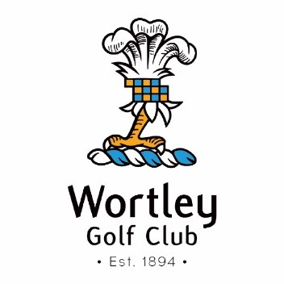

Sunday Lunches Dates

9th September - FULL

7th October 12.00 - 3.00 pm

28th October 12.00 – 2.00 pm (due to society booking)

4th November – Private Party Booking

18th November 12.00 - 3.00 pm

2nd December 12.00 - 3.00 pm

Please confirm your booking at the bar
Many thanks

