For enquiries and bookings please contact our Christmas elves.

£10.00 required per guest to secure the booking.
Pre-order meal choice booking forms are to be completed and returned by the 16th November for all party nights.
Full balance of the party to be received by the 1st December.

Leicester Road, Hinckley, LE10 3DR
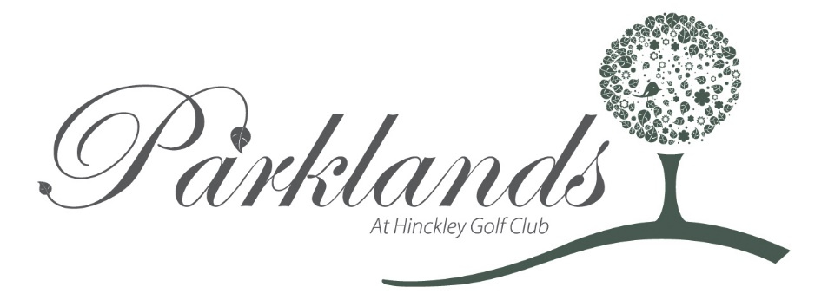
Call: 01455 560070
events@hinckleygolfclub.com

Christmas Day

Starters
Roast Squash & Parsnip Soup, Spiced Dressing, Parsnip Crips

Confit Duck 2 Ways – Crispy Drumstick, Thigh Rillette, Candied Orange Puree

Cured Salmon with Beetroot and Apple, Seared Scallops in Pancetta

Chicken Liver & Cognac Parfait, Date and Grape Chutney, Toasted Onion Bread

Baked Goats Cheese “Crottin” Stuffed with Confit Shallots wrapped in Filo Pastry,
Olive Tapenade, Baled Plum Tomatoes

****
Lemon & Lime Sorbet, Passionfruit Gel
****

Champagne on arrival
Desserts
HGC Christmas Pudding,
Almond Crumble, Vanilla and Advocaat Sauce

“Black Forest” Chocolate Stout Cake, Kirsch and Cherry Brandy Pannacotta,
Black Cherries in Port and Maraschino Liquor

Baileys and White Chocolate “Brulee”, Roast Plums, Rosemary Shortbread

Lemon Curd Meringue Roulade, Spiced Marmalade Ice Cream

Potted Stilton. Roast Figs and Honey Oatcakes
**********
Homemade Mince Pies & Coffee/Tea
**********

Mains
Turkey Parcel Stuffed with Apricot and Pork Sausagemeat,
Fondant Potato, Thyme and Port Gravy

Pan-roasted Seabass Fillets Stuffed with Crab on a Shellfish Bisque,
Saffron Cocotte Potatoes

Seared Tea Smoked Duck Breast Glazed with Rosemary Honey,
Granny Smith Puree, Lyonnaise Potato

Venison Wellington, Chateau Potatoes, Beetroot and Juniper Puree, Gratin Potatoes

Parsnip and Chestnut “Crumble” Tartlet,
Parmesan Croquettes, Spinach & Blue Cheese Cream
All served with seasonal vegetables

New Years Eve- Sparkle Ball
Champagne on arrival
Desserts
- Raspberry, White Chocolate and Drambuie Delice, Caramel and Almond Ice Cream
- Dark Chocolate Tart, Popcorn Ice Cream, Caramelised Orange

~~~
Coffee and Sweet Treats
~~~
Carriages at 1.30am
Starters
- Terrine of Confit Duck, Chicken and Foie Gras, Raspberry Vinaigrette, Aged Balsamic and Rye Bread Croutons

- Pastry Mille Feuille,
Creamed Goats Cheese,
Bergomot Poached Pear

Gin & Tonic Sorbet
Mains
- Cornfed British Chicken stuffed with White Pudding, Anna Potato, Maderia & Wild Mushroom Sauce

- Roast 28 Day Dry Aged Ribeye of Hereford Beef, Goats Cheese and Red Onion Mash, Port Jus

- Tian of Swede, Squash, Parsnip, Cauliflower Puree, Leek and Potato Fritter

