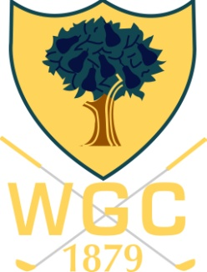

The 2016 De Vere Open
Prize Winners
Name/Score | 18 Hole Score | Back 9 | Back 6 | Back 3
1 Richard Day & Gary Wilkinson | 48 Points | 23 | 15 | 7
2 Nick Day & Rob Schooling | 47 Points | 25 | 14 | 7
3 Rich Sebok & Phil Park | 45 Points | 21 | 14 | 7
4 Gary Godwin & Chris Rawlings | 43 Points | 23CB | 17 | 10
5 Andy McCabe & Andy Fleming | 43 Points | 20 | 13 | 6

Best Gross: Steve Lane & Nigel Collins 69
Nearest The Pin on the 3rd: Phil Birch
Nearest The Pin on the 5th: Gary Wilkinson
Nearest The Pin on the 8th: Tim Cain
Nearest The Pin on the 15th: Duncan Macpherson

2’s Winners
Payout is: 1 Sleeve of Pro V1 per 2
C Bayliss on the 8th
P Lupino on the 3rd
D Turner on the 5th
T Cain on the 5th
P Mcilroy on the 5th
S Carter on the 15th
D Macpherson on the 15th
J Williams on the 3rd & 15th
G Wilkinson on the 5th
J Payne on the 15th
P Birch on the 3rd
J Allies on the 8th
P Clarke on the 8th (already taken balls)
N Axten Rice on the 15th (already taken balls)
J D Williams on the 15th
S Porritt on the 8th

