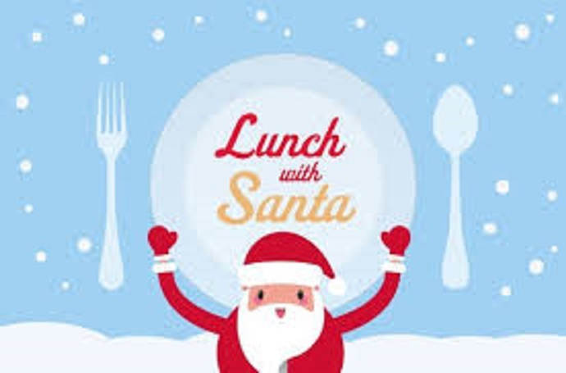

Lunch with Santa

Still few tickets left for lunch with Santa

Sunday 23rd December

£7.95 per child

